|  | USN 1RUABCA240075  **School of Computer Science and Engineering BCA (Hons.)**  **Continuous Internal Evaluation (CIE-3)**  **Question Paper**  **Academic Year 2024-2025** | | |
| --- | --- | --- | --- |
| **Course: Introduction to Version Control** | | **Course Code: CS1105** | **Semester: II** |
| **Time: 2.00 to 3.00 pm** | **Duration: 60 minutes** | **Date:15-04-2025** | **Max Marks: 15** |

**Notes/ Instructions: Answer all questions**

| **Sl.**  **No.** | **Question** | **Marks** |
| --- | --- | --- |
| **1.** | **Task 1: Git – Stashing Workflow (3 Marks)**  Clone a sample repository or initialize a new Git repo.  Modify an existing file (main.py) – add a print statement.  Stash your changes  Create a new branch  Modify or create another file (feature.py).  Apply stashed changes  Show the final changes and log  Submit a screenshot of git log and git status | **3** |
| **2.** | **Task 2: Git – Cherry-pick Commit (3 Marks)**  Create and switch to a branch feature1.  Add a file notes.txt and commit it.  Switch to main branch.  Cherry-pick the commit:  Show the commit history on main.  Push changes to GitHub. | **3** |
| **3.** | **Task 3: GitHub Copilot – Top 3 Even Numbers (3 Marks)**  Open VS Code with GitHub Copilot extension enabled.  Create a Python file named top_even.py.  Add comment:  # Write a function to return top 3 even numbers from a list  Accept Copilot’s suggestion and complete the function.  Add 2 test cases to check the output.  Comment on what Copilot generated and what you modified.  Screenshot or commit final code. | **3** |
| **4.** | **Task 4: GitHub Copilot – JavaScript Calculator (3 Marks)**  Create calculator.html and calculator.js.  Ask Copilot to generate basic arithmetic functions.  Style it minimally with HTML/CSS.  Comment on Co-Pilot’s output: Did it help with layout or logic? | **3** |

L1- Remember, L2- Understand, L3 – Apply, L4- Analyse, L5 – Evaluate, L6 – Create

Page 1 of 2

|  | Show final calculator and screenshot. |  |
| --- | --- | --- |
| **5.** | **Task 5: GitHub Copilot – Recursive Factorial (3 Marks)**  Create factorial.py.  Comment:  # Recursive function to calculate factorial  Let Copilot generate the function.  Test with input 5, 0, -1.  Comment on edge case handling and Co-Pilot’s suggestion. | **3** |

**Task 1: Git – Stashing Workflow (3 Marks) :**

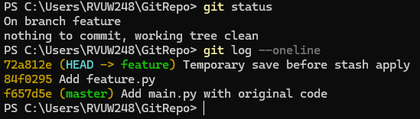

**Task 2: Git – Cherry-pick Commit (3 Marks):** 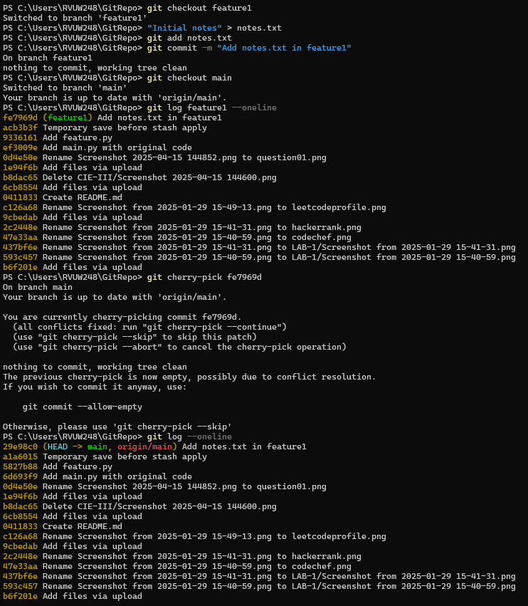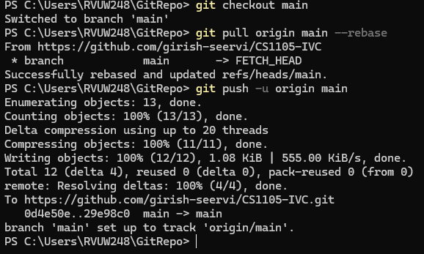

**Task 3: GitHub Copilot – Top 3 Even Numbers (3 Marks) :**

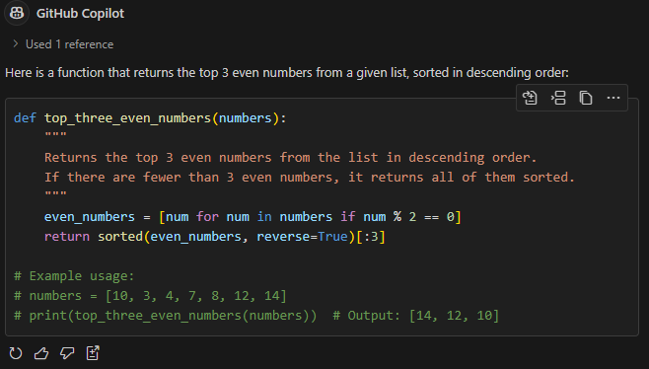

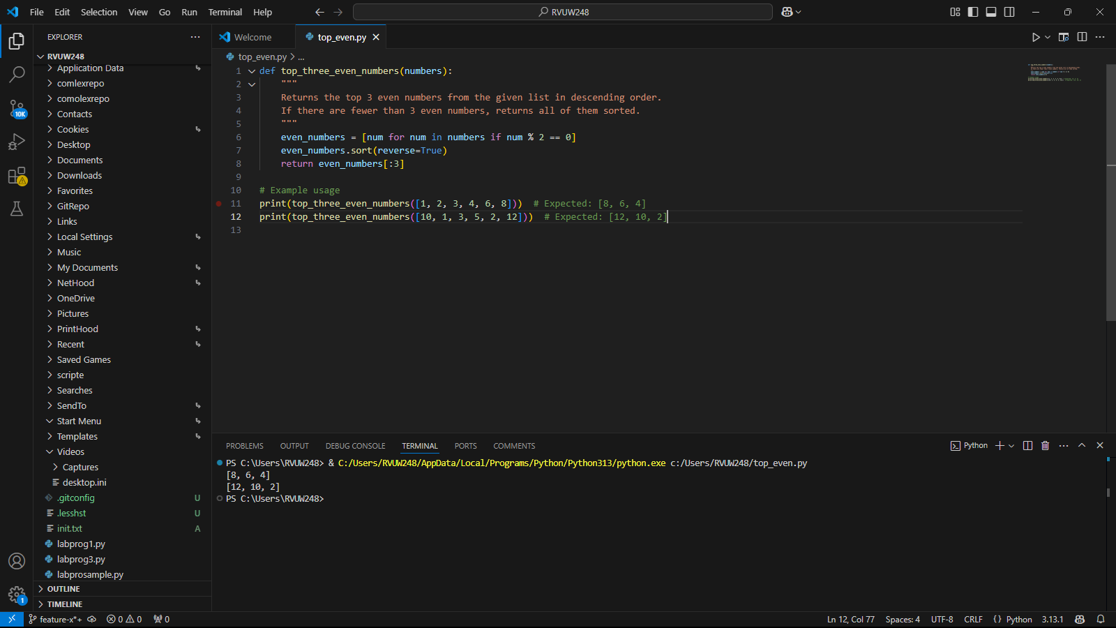

**Task 4: GitHub Copilot – JavaScript Calculator (3 Marks) :**

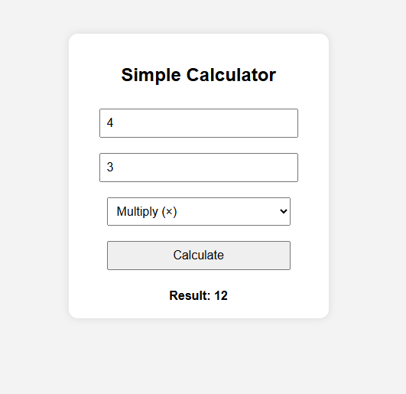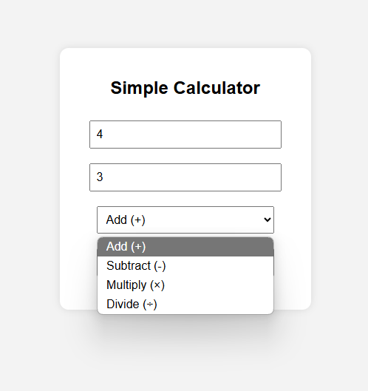

**Task 5: GitHub Copilot – Recursive Factorial (3 Marks) :**